Ideation Phase

Brainstorm & Idea Prioritization Template

|  |  |
| --- | --- |
| Date | 18 June 2025 |
| Team ID | LTVIP2025TMID52343 |
| Project Name | **DocSpot:** Seamless Appointment Booking for Health |
| Maximum Marks | 4 Marks |

**Brainstorm & Idea Prioritization Template**

# Purpose:

This template is designed to support collaborative idea generation and decision-making. It creates a space where team members can express thoughts freely, think creatively, and work together to solve problems efficiently. Whether your team is working in person or remotely, this structure ensures that every idea has a chance to be heard and considered.

# Why Brainstorming Matters:

Brainstorming helps teams unlock creativity, gain new perspectives, and generate a wide range of solutions to a single problem. It breaks traditional boundaries and promotes collective thinking. Every contribution counts — from practical to imaginative.

# How It Works:

* Encourage open participation without judgment or filtering of ideas
* Focus on generating as many ideas as possible — volume leads to variety
* Welcome unconventional or bold suggestions
* Collaborate actively by expanding on each other's thoughts
* After listing, sort ideas into categories or groups (clustering similar thoughts)
* Use prioritization techniques like voting, scoring, or impact-effort matrices

# Key Guidelines for Effective Brainstorming:

* Set a clear goal or problem statement
* Limit the time (e.g., 20–30 minutes) to keep energy high
* Create a safe, inclusive environment where all voices are respected
* Use visual aids (e.g., sticky notes, digital boards) to organize and display ideas
* Avoid criticism — focus on building up, not tearing down

# Prioritization Techniques You Can Use:

* **Dot Voting** – Team members vote for their top choices using colored dots
* **ICE Scoring** – Rank ideas by Impact, Confidence, and Ease
* **MoSCoW Method** – Sort ideas into Must Have, Should Have, Could Have, and Won’t Have
* **Effort vs. Impact Matrix** – Plot ideas to identify quick wins and high-value tasks

# Benefits of Using This Template:

* Promotes team alignment and shared understanding
* Makes the decision-making process faster and more transparent
* Helps avoid bias by giving equal weight to all contributions
* Supports both in-person and remote team collaboration
* Encourages innovation and creative problem-solving

Reference: <https://www.mural.co/templates/brainstorm-and-idea-prioritization>

# Step-1: Team Gathering, Collaboration and Select the Problem Statement

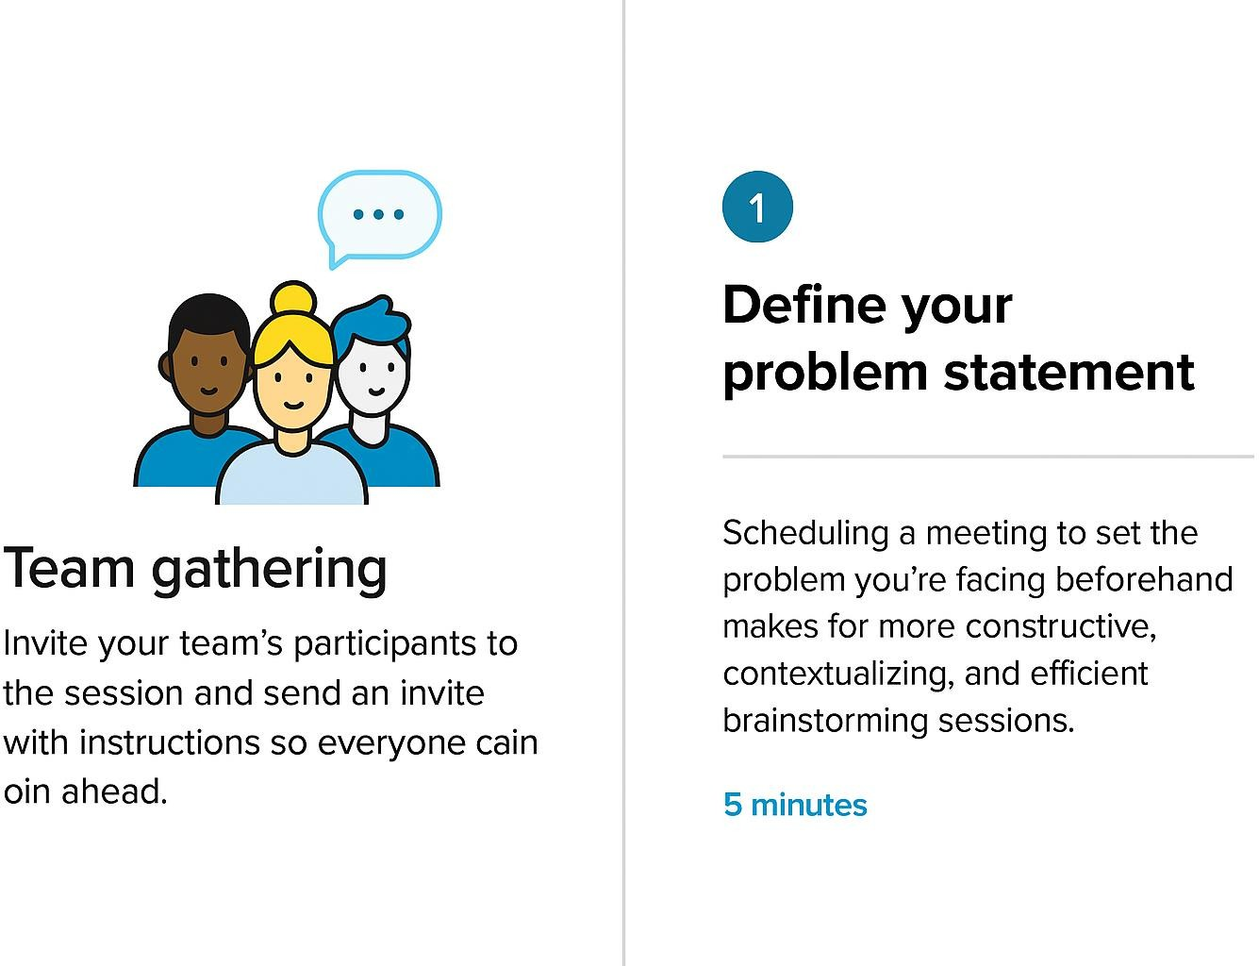

**Step-2: Brainstorm, Idea Listing and Grouping**

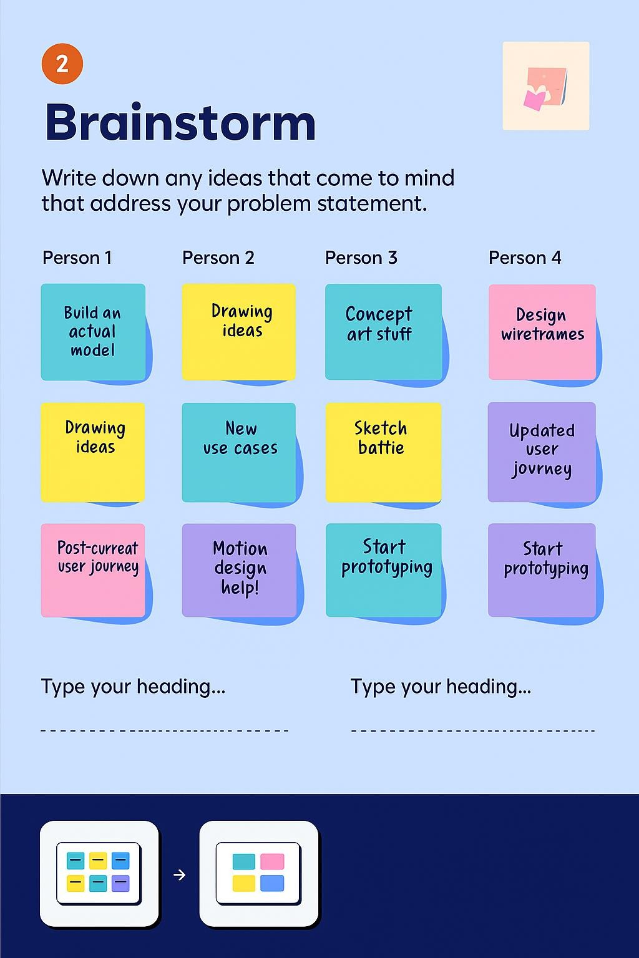

**Step-3: Idea Prioritization**

